Figures and Tables:

The figures 3.1 to 3.3 show the data from the first dataset. The data of patients 1,2 and 3 have been denoted in each of the graphs. In the first graph, we see that as time surges, the ECG value keeps on increasing and decreasing but it never is bigger than the value of time. They have a linear relationship. The second graph also shows the same, that is, we see that as time increases, the ECG value also increases but it is never larger than the value of time. They also have a linear relationship. We also see that in many cases, ECG value does not decrease with time, but stays constant, as shown by the empty spaces as time increases. The third graph is not any different, that is, as time increases, the ECG value also increases but it is never larger than the value of time. Even they have a linear relationship.

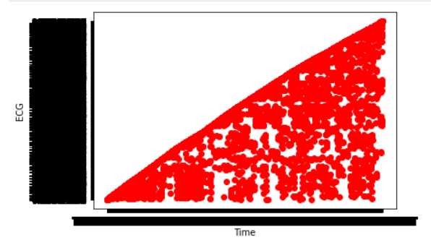

(Fig 3.1: ECG vs Time of Patient 1)

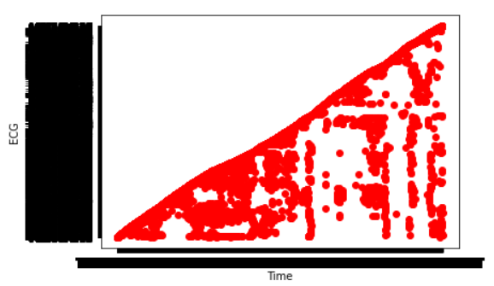

(Fig 3.2: ECG vs Time of Patient 2)

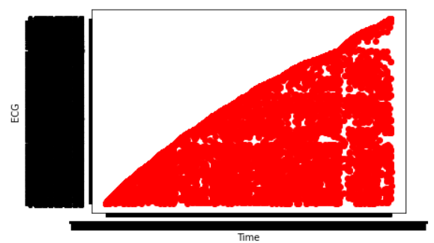

(Fig 3.3: ECG vs Time of Patient 3)

The figures 3.4 to 3.6 show the data from the second dataset. They show the results of Count_ICD9 vs Population_ICD9, ObsRate_ICD9 vs RiskAdjRate_ICD9 and Count_ICD9 vs ObsRate_ICD9 respectively. In the first plot, we can see that Population_ICD9 is almost always larger than Count_ICD9, with the exception of a few. In the second plot, we cannot discern any pattern at first, but on a closer inspection, we can see a linear growth among both the axis values. In the third plot, again, we can say that there is a linear relationship that exists among the values. However, in the third graph, not a lot of values appear to be at the high extremes. This is in contrast to the second graph, where there are numerous values in the high extreme. Nevertheless, in all the three graphs, we can see that there are more values in the lower extremes compared to the higher extremes.

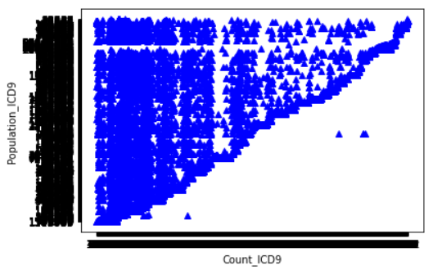

(Fig 3.4: Count_ICD9 vs Population_ICD9)

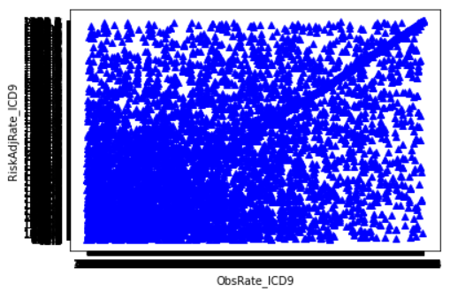

(Fig 3.5: ObsRate_ICD9 vs RiskAdjRate_ICD9)

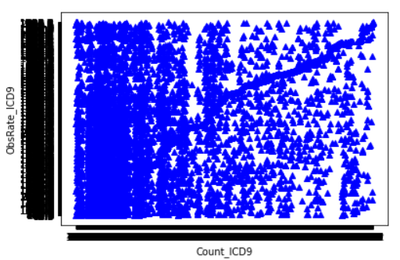

(Fig 3.6: Count_ICD9 vs ObsRate_ICD9)

The figures 3.7 to 3.9 show the data from the final dataset. They show the plots of Data Value vs Low Confidence Limit, Data Value vs Year and Low Confidence Limit vs Year respectively. In the first graph, we can observe that some of the Low Confidence Limit values are high compared to the Data Value values, whereas some are low. Most of the times, as Data Value increases, Low Confidence Limit remains constant, or in rare cases, increases. We can see that after the Data Value reaches 2500 approximately, Low Confidence Limit is constant. The second and third graphs are plotted as horizontal and vertical lines respectively since Year is constant. In the second graph, we can see that each Year, most of the range of the Data Values lie in the lower range, whereas in the third graph, we can see that each Year, Low Confidence Limits exists in both the lower as well as the higher ranges, with values appearing rarely in between 2500 and 3000.

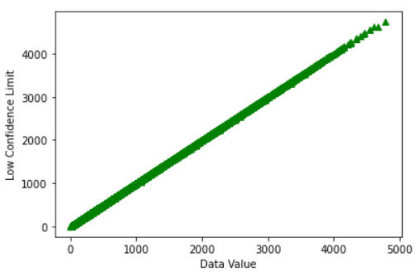

(Fig 3.7: Data Value vs Low Confidence Limit)

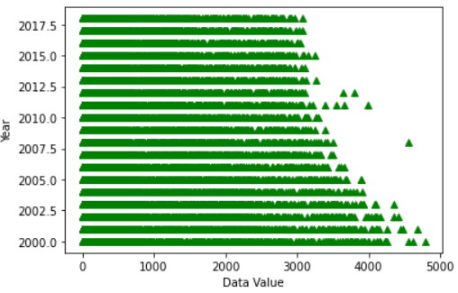

(Fig 3.8: Data Value vs Year)

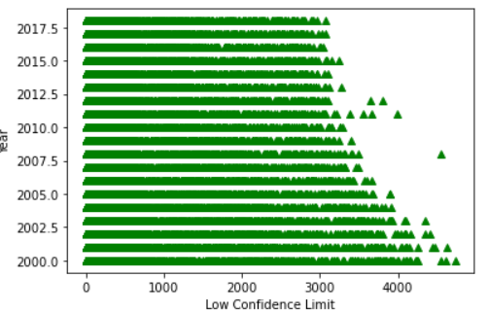

(Fig 3.9: Low Confidence Limit vs Year)

Table:

|  |  |  |
| --- | --- | --- |
| Dataset | P-value obtained | Inference |
| Dataset – 1 | 1 | Null Hypothesis accepted |
| Dataset – 2 | 1 | Null Hypothesis accepted |
| Dataset – 3 | 1 | Null Hypothesis accepted |